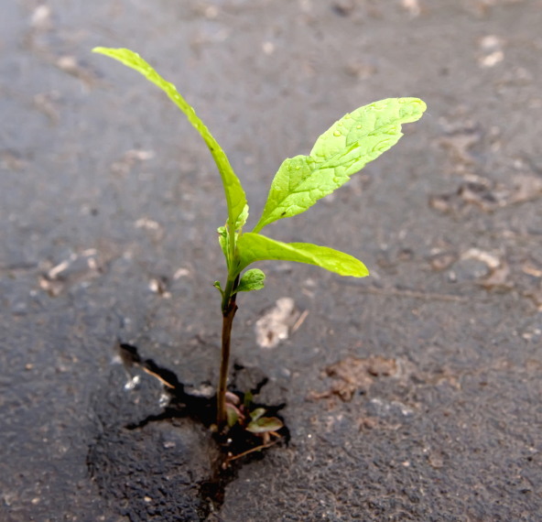
Grant Application

Part A: Who, Where and When
Name of Organization | Mailing Address | City: | Postal code:
Primary Contact Person: | Primary Contact Phone Number: | Primary Contact Email:
Secondary Contact Person(s): | Secondary Contact Phone Number(s): | Secondary Contact Email(s):
*Please Note: Only primary contacts will receive communication regarding this application. Should the primary contact change following submission, please contact us at healthycommunities@northernhealth.ca.
Project Name: |  | Project Start Date: | Project End Date:
Project Location: In what community (communities) does your project take place?

Project Reach: Please estimate the number of people who will be attached by the project. (Select ONE):
0 to 10 people 101 to 1,000 people Over 1,000 people

Part B: What, Why and How
Community resiliency exists where a community is able to respond to, withstand, adapt, and recover from adverse situations. This funding supports groups and organizations who need assistance adapting their practices and/or responding to new community health and wellness needs as a result of COVID-19. Considering this what changes does your project address within your organization or at the community level?

What action will you take to address this? Please be as detailed as possible, including steps and milestones that will help you reach your goals. When planning your project, please be mindful of all relevant public health orders, notices, and guidance.

Are you partnering with other organizations? If yes, please describe any partners and what their role in your project will be. Partners cannot be part of your organization. Example: If a teacher is applying they cannot list another teacher in another department as a partner.

Part C: Project Budget
Please Indicate all expenses for your project in the table below, as well as all sources of funding. Complete this section as follows:

- In Table 1, list all project expenses by item, such as materials, equipment, and other fixed expenses

- Indicate whether you are requesting for each item to be funded by NH or if you have funding from another source

- Add up total project expenses and total requested from Northern Health and place in the appropriate boxes (Amount requested from NH should not exceed $5,000)

- If there are other sources of funding for this project, complete Table 2

TABLE 1
Project Expenses |  | Funding Source
Expense (e.g. Materials, Equipment) | Amount ($) | Funded by NH | Other Funding (Y/N)
TOTAL Project Expenses | $
TOTAL Requested from NH |  | $

TABLE 2
If your project requires more funding than you are requesting from NH, list all other funders, the amount they are contributing, and whether or not they are confirmed.
Expense (e.g. Materials, Equipment) | Amount ($) | Confirmed (Y/N)
TOTAL
Part D: Additional information
Please provide any additional information you would like us to review in consideration of your application and ensure you attach it to the email when you submit. This can include diagrams, articles, PowerPoint presentations, reports, pictures, stories, etc.
Cost quotes for items to be purchased are helpful.

Part E: Submitting your grant application
If submitting this application electronically or by fax, you will receive an email confirmation within 48 hours. Please contact us by phone or email if you do not receive confirmation.

Email: healthycommunities@northernhealth.ca

Contact information
Healthy Community Development-Community Granting Scotia Bank
1488 4th Avenue Suite 400 Prince George, BC V2L 4Y2
Phone: 250-565-2131
Fax: 250-612-0810

What can we do better?
Please take a second to tell us about your experience applying for a Northern Resilient Communities Grant. We are constantly improving on the work we do for you, so if any part of the process didn’t work, let us know so we can try to fix it!

Any questions?
We have done our best to create an application that is easy to fill out and assists Northern Health and our Northern Resilient Communities Grant recipients to learn from their projects. Please ensure that the application is fully completed, and that your project is explained as clearly as possible. In order to fairly evaluate your application, it is very important that the screening committee can fully understand your proposal. If you have any questions or need more information prior to submitting your application, please do not hesitate to contact us by email or phone and we will be happy to help.
Please be advised that a signed contract letter between Northern Health and each successful applicant will be required before release of funds. A final evaluation report will be required upon completion of the project (date will be determined and shared with all applicants).

Northern Health collects, stores and shares your personal information under the authority of the Freedom of Information and Protection of Privacy Act (British Columbia). Northern Health will take all reasonable steps to make sure your personal information is treated confidentially and stored securely. If you have any questions, please contact Northern Health’s Privacy Office at 250-565-5822.

